OVEREATERS ANONYMOUS SPRING WORKSHOP
BROUGHT TO YOU BY:
BIG SKY INTERGROUP
Saturday, march 18th, 2023
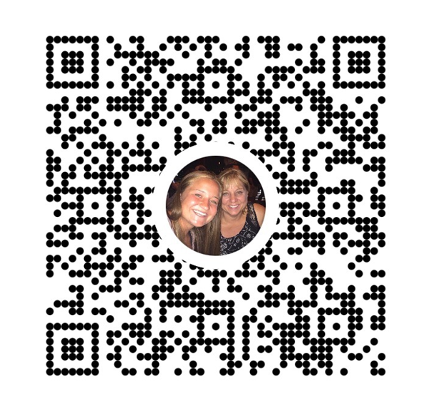
10:00 am – 4:00pm (Registration opens at 9:30)
Billings Public Library
510 N. Broadway
Cost: $20 at the door or Venmo
virtual option available
For more Registration info contact:
Teri C: (406) 876-0198 OR Tani M. (406) 860-9881
*** 2 Speakers from Region 1 will share their stories ***
Workshops: ~ Body Image AND ~ Relapse
What to Bring: Big book, OA 12 x 12, Notebook.
Lunch on your own (fridge & microwave available).

