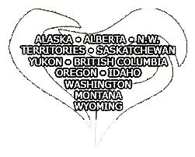
Need a sponsor?
Or, are you an available sponsor willing to help someone remotely via phone, email, Skype, or FaceTime?

To help members who are unable to find a local sponsor, Region One offers “Virtual Sponsorship!”

How does it work? Submit an application as a sponsor or sponsee. The VS Team then try to “match” you with available sponsors/ sponsees, and share contact info so that you can talk and decide if you’d like to work together.
For more information or to fill out an application, visit http://www.oaregion1.org/find-a-sponsor-or-sponsee.html
Or email Region1VirtualSponsorship@gmail.com.

Together we can!

