Bitterroot Intergroup OA Fall Retreat
September 29 - October 1, 2017
BOULDER HOT SPRINGS
Boulder, MT

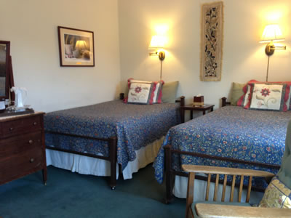
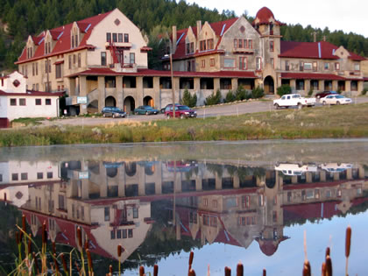

Speaker Big Book enthusiast from St. Louis, Missouri

Cost $45 — Retreat Registration
$80 — Lodging per room per night (double occupancy)
$90 — Six meals: Fri dinner—Sun lunch (individual meals may be purchased)

Payment Retreat Registration
Make your $45 check payable to: Bitterroot Intergroup
("2017 Fall Retreat" noted in memo section).
Mail $45 Retreat Registration checks to: Kate V., 16002 Bridger Canyon Road, Bozeman, MT 59715.

Room and Meals
Call Boulder Hot Springs directly (406-225-4339) to reserve your room and order your meals. To be eligible for the “group rate,” let them know you will be attending the OA retreat. “Bed & Breakfast” rooms with full baths are available for $100/night. If you have special dietary restrictions or needs, please inform the staff as you make your reservations. Boulder Hot Springs is very accommodating.

Info Info Website: http://falloaretreat.wixsite.com/falloaretreat

Phone: Kate V. at 406-586-0549

Scholarships Scholarships are available: Contact Intergroup Treasurer Jackie S. by phone at 406.250.8958 or email at Jackiestro42@gmail.com.
Don’t forget to bring…

- Big Book
- Notebook
- Pens/pencil/highlighters
- Item to contribute to the silent auction drawing
- Anything needed for personal dietary restrictions
- Swimsuit (should you wish to go in the hot springs)
- Indoor shoes/flip-flops for walking to and from the pool
- Walking shoes and a bike if you wish to walk the grounds or bicycle the dirt roads

Schedule

Friday, Sept 29
3:00-5:00 Registration 6:00-7:00 Dinner
7:30-9:00 Main Speaker

Saturday, Sept 30
8:00-9:00 Breakfast
9:15-11:45 Main Speaker
12:00-1:00 Lunch
1:15-3:45 Main Speaker
4:15-5:45 BIG* Meeting
6:00-7:00 Dinner
7:30-9:00 Main Speaker 9:15-10:00 Raffle
Sunday, October 1
8:00-9:00 Breakfast
9:15-10:45 Main Speaker
11:00-11:45 Open meeting
12:00 Lunch

​
About Boulder Hot Springs

Montana’s historic Boulder Hot Springs Inn and Spa is located almost mid-way between Butte and Helena just off Interstate 15. It rests in the midst of southwest Montana’s spectacular beauty of snow-capped mountains and lush valleys. The Inn & Spa sits on almost 300 acres of pristine meadows, wetlands and forest. The air is pure and the sounds you hear are those of nature. The Inn is backed by Deerlodge National Forest, home to bears, moose, elk, deer, fox, antelope and coyotes.

Our Inn offers a combination of comfortable, inviting, elegant and luxurious B&B rooms and suites for guests who want the best that a healing, homelike atmosphere has to offer, and guest rooms for our more budget-minded guests.

Our greatest attraction is our mineral-laden, pure geothermal waters, which are used in the indoor plunges, the outdoor swimming pool, the natural mineral steam rooms, the showers, and also to heat the entire building.

Since we specialize in healthy, healing, active living and luxury at an affordable price, Boulder Hot Springs Inn and Spa, with the Conference and Retreat Center, has chosen to be an alcohol, drug and smoke-free environment.

Our kitchen specializes in a variety of healthy, home-cooked, interesting and delicious gourmet food. We use organic meats, fruits and vegetables whenever possible and we serve “Montana-grown” specialties. Boulder Inn and Spa has always been famous for its buffets and we have strived to continue that tradition serving prime rib, fresh seafood, Native American and International cuisines at our buffets. We also have a broad range of menus to choose from for retreats, workshops and conventions.

http://www.boulderhotsprings.com/ *BIG=Bitterroot Intergroup

